Hello!

Thank you for your interest in contracting with Devoted Health Plans. We have top doctors, cutting edge technology, and personalized care teams that help us provide high quality healthcare to our members. We’re on a mission to make healthcare better — learn more about the Devoted Health Difference! We are excited to partner with you and look forward to working together.

Your Commission Type:

DIRECT PAYEE
This means your enrollment commission will be paid directly to you by Devoted Health. You must receive a Ready To Sell* email before you can market Devoted Health in any market.

INDIRECT PAYEE
This means your enrollment commission will be paid to your Agency and they are responsible for compensating you for your Devoted Health Medicare enrollments. You must receive a Ready To Sell* email before you can market Devoted Health in any market.

How to Get Started in Agent Portal:
- Create an Account using [INSERT LINK]
(Existing Agents: log into your existing account)
- Complete Onboarding
- Start the Certification Process
Important Things To Know:
- If you have completed the Core Medicare training, we accept AHIP, PinPoint and NABIP (formerly NAHU) certificates. If not, you can now complete the AHIP training and get a $50 discount if training is completed by September 19th, 2024. The link will also be available in our certification workflow. While you can continue to access AHIP training through the Devoted Health link on September 20, 2024 and going forward, the discount will no longer be available after this date.
- Completing the PY2025 Certification will also allow you to market PY2024 benefits in our current Devoted Health service areas.
- The Devoted Health Product Training & Exam informs you on how to compliantly market Devoted Health benefits and satisfy the annual CMS Medicare Compliance Program requirements.
- To receive renewals for business sold in prior years, you must be licensed and appointed to sell Medicare products per state laws and recertified annually.
- A face-to-face certification is not required.
- For more guidance, please refer to the Devoted Agent Portal Quick Start Guide or visit us at www.devoted.com/brokers.

What Happens Next?

Agent Onboarding and Certification Process Overview:
- Account creation for Devoted Health’s Agent Portal
- W-9 & Direct Deposit (Direct Payees only)
- Agent Questionnaire
- Code of Conduct Acknowledgement
- Agent Agreement
- Background Check Consent
- Core Medicare Training or equivalency upload (AHIP or Pinpoint)
- CMS Fraud, Waste & Abuse & Compliance Training
- Devoted PY2025 Certification Training & Exam
- Agents will have 3 attempts to pass the training exam with a minimum score of 85%
- Each time the exam is opened (initiated) it will count as an attempt and must be completed in one sitting (~40 min).
- License Check
- RTS Status**
The agent's progress will be saved if they cannot complete the certification all at once — they will be able to continue at a later time, with the exception of the Devoted Health training exam.

Agents Ready to Sell Status:

Once the appointment process for the agent's respective state(s) is complete, they will receive an email notification that they’re “Ready to Sell” (RTS) for PY2025*. Agents cannot market or sell Devoted Health benefits until they receive this email.

Here's why it’s easier than ever to sell Devoted Health Medicare Advantage plans


Fast certification
Save time and get certified in 1 hour or less


Easy on-boarding
95% of brokers said certifying with us was a better experience and a smooth process compared to other carriers²


National expansion
We’ve added 7 new states and will be in 600+ counties in 2025


More sales opportunities
This AEP, we’ll be accessible to 1 in 3 Medicare eligibles³

See where we're going next in 2025

Get more chances to sell as we head into seven new states, plus even more counties in our existing states.

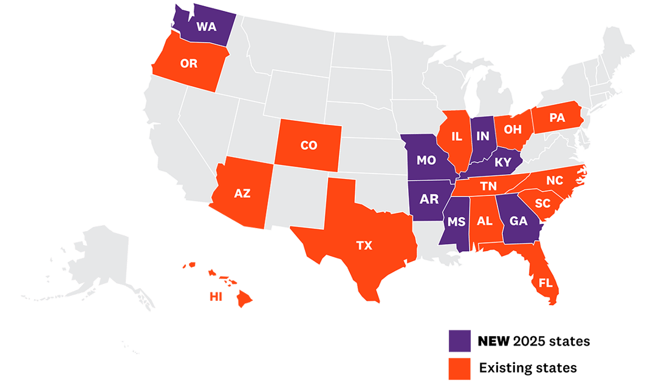


1 - Medicare Advantage/Part D Contract, Enrollment Data, Centers for Medicare & Medicaid Services, 2024. In AEP 2024, Devoted was the fastest-growing Medicare Advantage plan based on annual membership (for plans over 50K members, excluding 800-series plans).
2 - Devoted Health post-AEP survey, 2023.
3 - CMS Monthly Enrollment by Contract/Plan/State/County
To enroll in a Devoted Health plan, you must meet certain eligibility requirements and reside in the plan’s CMS-approved service area. Our plans’ 2024 service areas, as applicable, include select counties in Alabama, Arizona, Colorado, Florida, Hawaii, Illinois, North Carolina, Ohio, Oregon, Pennsylvania, South Carolina, Tennessee, and Texas. 2025 service area depends on CMS contract approval.

CONFIDENTIAL - For broker/agent use only. Not for distribution to Medicare beneficiaries.

