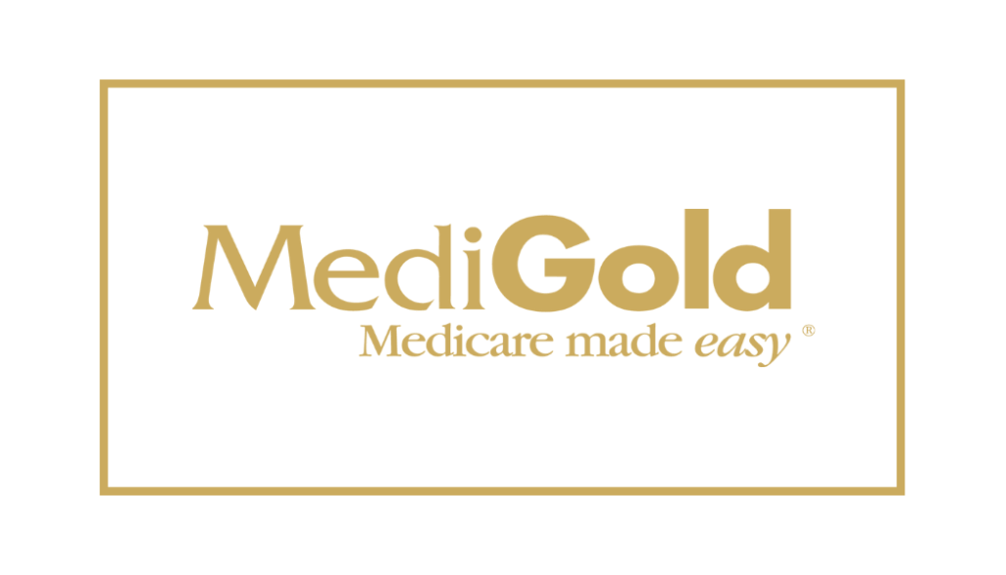

CERTIFICATION
- 2024 Certification NOW OPEN
- Go to MediGold Certification
  - Agent will be prompted to enter an access code. 1262MG2024. Important: Click on the ‘Register New Program’ button prior to “Enter the Access Code”.
- 2024 training covers remainder of 2023

GUIDES & SUPPORT
- Good to know! Take the steps to go through the certification. Note there is NO TEST. When done, it takes a couple of days to show ‘completed’. You will receive an email confirming you are RTS. To obtain you certificate, log into your Miramar account, click the ‘Documents’ tab on the toolbar. When you’re in the Document Management page, click the 2024 MediGold Product Training box to open your certificate.
- Pre-AEP Broker FAQ
- Miramar Help Desk 855-828-8530
- Broker Portal User Guide

